23.38: a) 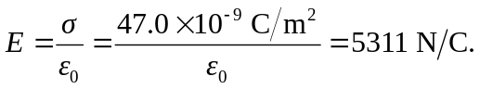
b)
c) The electric field stays the same if the separation of the plates doubles, while the potential between the plates doubles.

